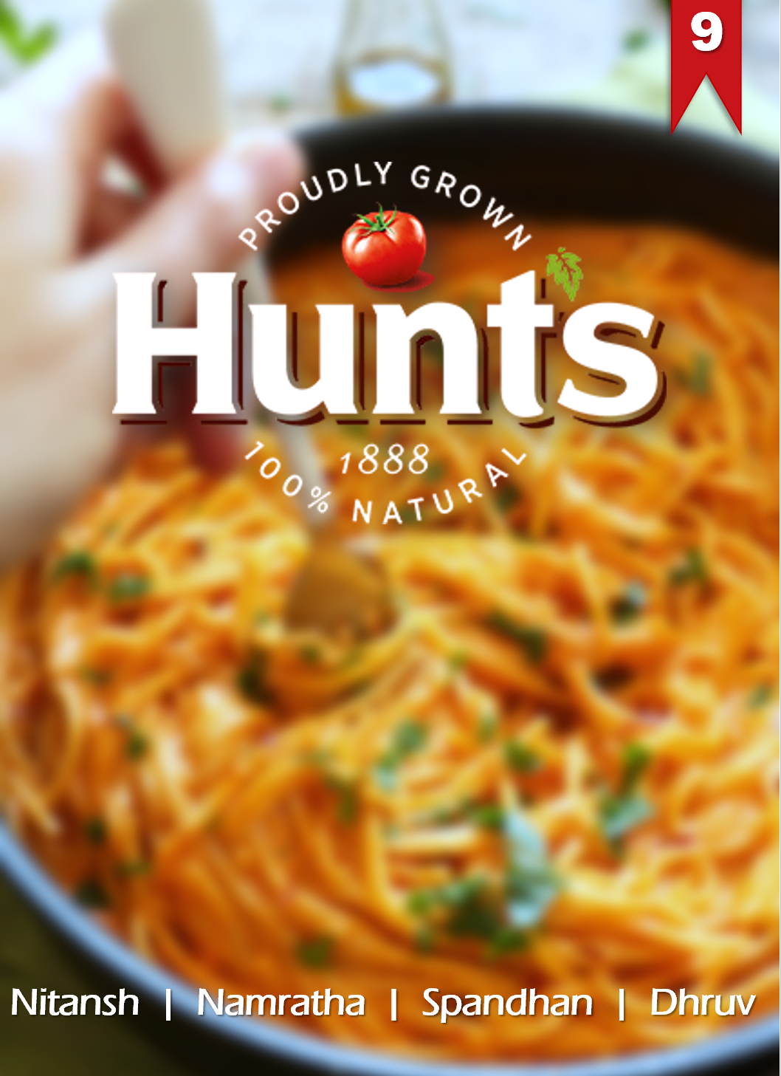

**Group**

***Introduction:***

* ***HUNT’S*** is the name of a brand of preserved tomato products owned by Conagra Brands. In Spaghetti Sauce category, it was the 6th largest brand in terms of revenue share, in 2001. As Brand Managers **we try to predict parameters and their influence on the sales Spaghetti sauce**. (From here onwards we might refer our product as HSS.) Analyze competitor information to uncover industry trends.

We started with three questions:

Q1: What brand and market parameters affect/improve the revenue sales?

Q2: What parameters affect consumer decision for HSS’ selection?

Q3: How does the current/prospective HSS’ consumer look like?

By solving these three questions we aim to answer the main question: How to Sell More?

Revenue, customer decision, future customer

(Fixed effects 🡪 PREDICT SALES, conditional logit-🡪 PE, RFM🡪 Demographics)

***Procedure:***

We used *Fixed effect model* to predict sales of our product, and *conditional logit* for predicting price elasticities for our brand. At the end we used *RFM* to cluster spaghetti sauce user base to evaluate demographics of our existing/

potential customer base.

We also added/tested some calculated variables like:

**Volumetric Price Index:** per lb price($) of HSS / Average per lb price($) of top 6 brands. *Created to check if a deviation in HSS’ price-per-volume from market average changes any sales parameter.*

**Unit Market Share:** for a given weekHSS’ unit sales in previous 4 weeks divided by unit sales of top 6 brands in the same duration. Consumers follow trends, hence to check if the recent past sales trends of HSS compared to competitor brands make any difference. It can also be perceived as HSS’ market share in last 4 weeks.

**F_hlw, F_o:** against every sale of HSS we not only considered, the ongoing F, D and PR parameters, but also the ones in Last week (F_HuntsLastWeek) and for other brands (f_Others).

**Loyalty**: for every consumer(panID) %age of HSS’ units purchased over total units purchased in the category.

***Analysis 1: Predicting HSS’ Sales (Fixed Effect Model)***

With a balanced panel data representing the sales of spaghetti sauce over a year, we first ran panel regression model with random effects estimator. The “Hausman Test for Random Effects” table shows that the null hypothesis is that the random-effects model is appropriate for data is rejected. Hence fixed effects is used to overcome this uncertainty.

The panel data looked like:

 F, D, PR were converted into binary dummy variables

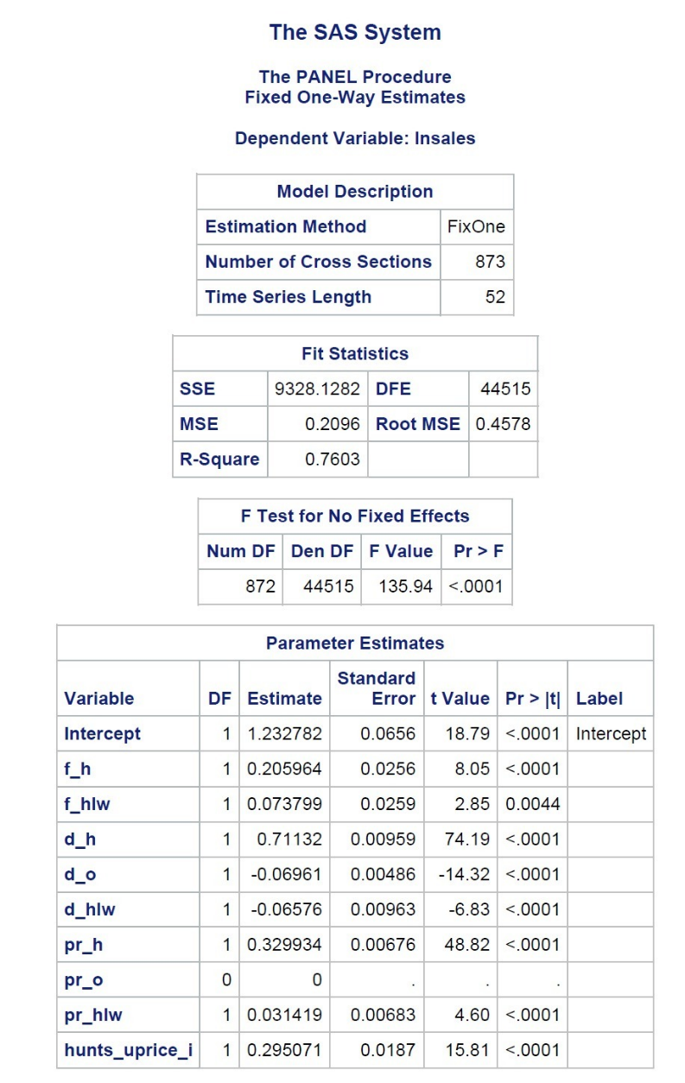**Model: ln(sales) = f_h f_hlw d_h d_o d_hlw pr_h pr_o pr_hlw hunts_uprice_i**

**Interpretation of Parameter estimates:**

**f_h** : If HSS put up a feature for their brand, the sales of spaghetti sauce increase exponentially by 0.206 times when compared to not putting up a feature.

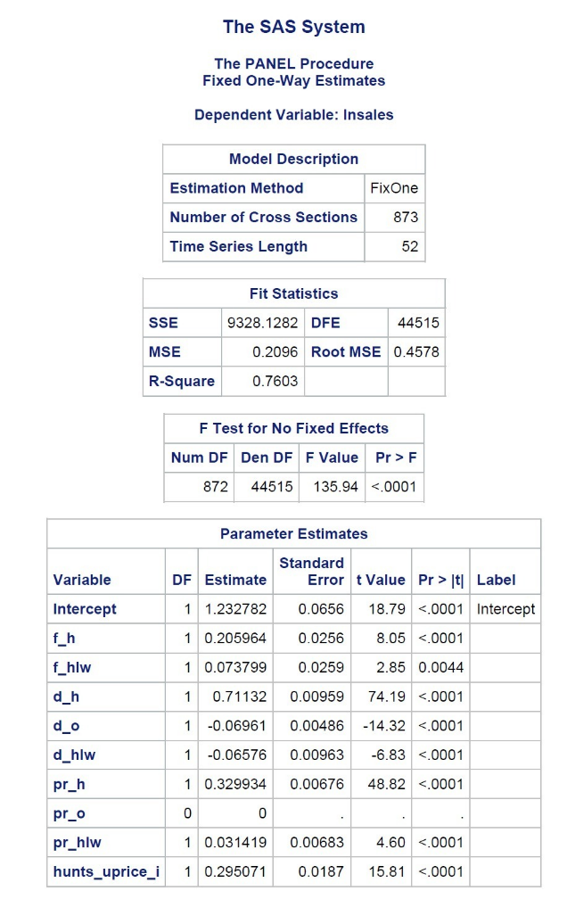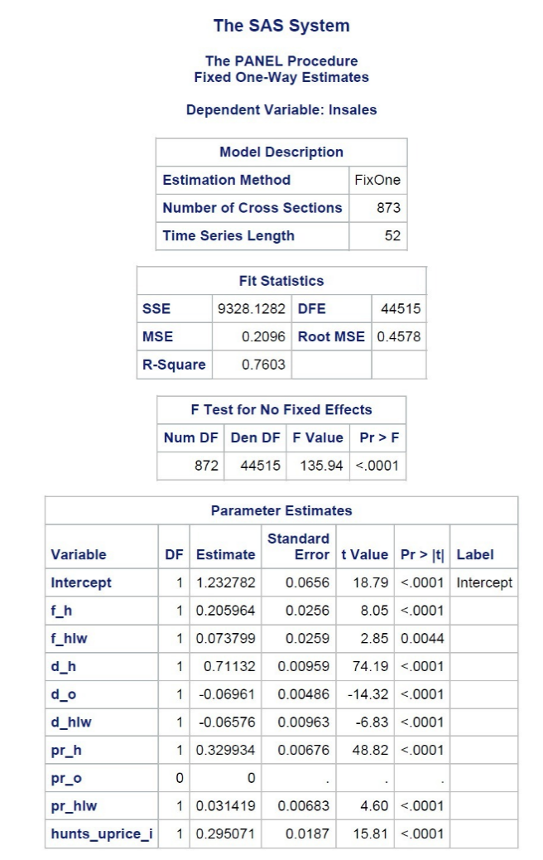**f_hlw:** If HSS had put up a feature the previous week and also puts a feature with the current week, the sales of spaghetti sauce increase exponentially by 0.074 times when compared to not putting up a feature current week.

**d_h:** If HSS have a display for their brand, the sales of spaghetti sauce increase exponentially by 0.711 times when compared to not having a display.

**d_o:** If other brands have a display for their brand, the sales of spaghetti sauce for Hunts decreases exponentially by 0.069 times.

**d_hlw** : If HSS had put up a display the previous week and have a display in the current week also, the sales of spaghetti sauce decreases exponentially by 0.066 times when compared to not having a display the current week.

**pr_h**: If HSS have a price reduction tag for their brand, the sales of spaghetti sauce increase exponentially by 0.329 times when compared to not having a price reduction tag.

**pr_hlw**: If HSS had a price reduction the previous week and continues it with the current week, the sales of spaghetti sauce increase exponentially by 0.314 times when compared to continuing the price reduction.

**hunts_uprice_i**: If the average price per Lb. of spaghetti sauce is $1, and Hunts puts a price of $1.1, then its sales will increase exponentially by 0.295 times

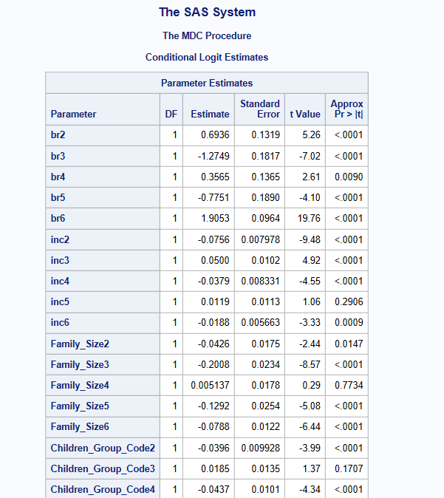***Analysis 2: Predicting ODDS of selecting HSS’ (Fixed Effect Model)***

**Interpretation of Parameter estimates:** Interpreting these results gives us which brand is more favored under what demographics.

* In compared to Hunts people with higher pretax income are more likely to choose the brands Classico and Five Brothers.

*Classico > Five Brothers > Hunts > Others > Ragu > Prego*

* In compared to Hunts people with larger family size are more likely to select Ragu (very marginal comparison).

*Ragu > Hunts > Prego > Others > Five Brothers > Classico*

* 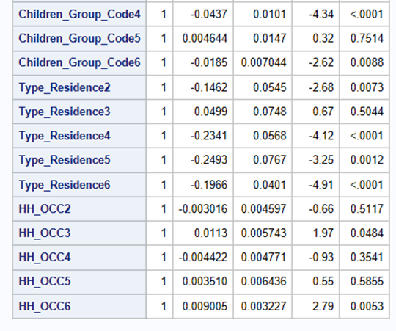In comparison to Hunts people with more children in their houses tend to choose Classico and Five Brothers

*Classico >Five Brothers >Hunts > Others > Prego > Ragu.*

* Compared to Hunts people with houses prefer Classico

*Classico > Hunts > Prego > Others > Ragu > Five Brothers*

* In compared to Hunts people with occupation prefer Classico, Five Brothers and Others.

*Classico > Five Brothers > Others > Hunts > Prego > Ragu*

***If one seeks to study transportations, for example, there will be four types of transports (car / train / plane / bike), each type of transport having its own characteristics (their price, their environmental costs...) but an individual can choose only one of four transportation***

*proc sort data= project.panel_RFM out= project.panel_RFM_data;*

*by DESCENDING Recency_value;*

*run;*

***Analysis 3:*** ***Identifying Customer Segments (RFM)***

We looked at the Recency Frequency Monetary aspects of the consumer behavior and scored them based on their ranks. Further we gave weights to the R, F and M parameters and used them to form 3 major user clusters

The table below shows the clusters form and the RFM groups in them. A group 321 represents consumers with highest recency, second highest frequency and lowest monetary contribution. The most differentiating demographic aspects of each group are also included in the table. We also looked at the other demographic factors and with intuitive personality traits (that matched with demographics) we formed three personas.

|  |  |  |  |
| --- | --- | --- | --- |
| **Parameters\Cust. Segments** | **Cluster 3** | **Cluster 2** | **Cluster 1** |
| **Platinum** | **Gold** | **Silver** |
| RFM groups >> | 223, 233, 313, 323, 332, 333 | 112, 122, 123, 132, 133, 212, 213, 221, 222, 232, 311, 312, 321, 322 | 111, 121, 211 |
| Sales Contribution | 69% | 26% | 5% |
| Customers | 31.29% | 39.65% | 29.07% |
| Recency(weeks)* | 4 | 9 | 18 |
| Frequency* | 15 | 5 | 2 |
| Monetary* | $ 35.58 | $ 11.69 | $ 3.36 |
| Annual HH Income* | $45K to $55K | $35K to $45K | $25K to $35K |
| Family Size* | 3 | 2 | 2 |
| HH Female Employment Status | High presence of Employed Women (full-time and par-time) | Almost equally high representation of women from all career categories | Higher representation of Retired, Un-Employed, Home Maker women |
| Male & Female Age Group | 35-54 | 25 - 54 | 45-64 |

*Median

We classify Spaghetti consumers in 3 ordinal categories:

*Platinum Customers:* Affluent people in late 30’s to early 50’s age group who love fine food. They represent the top income group in US. Such household have well earning class of women with manageable above median family size. They love to buy premium food and beverage products and more likely to purchase food articles like spaghetti sauce, that reduces cooking efforts. They are less likely to.

*Gold Customers:* They represent the average American. They represent every demographic present in the country. They buy food and beverages balancing time and money constraints. They are focused early career employees/workers/entrepreneurs.

*Silver Customers****:*** They represent the groups of Professionally Retired + old aged and Mid life + low earning class of the American society. They keep needs above wants and live a simple life. They are more likely to check the price tag on the food/beverage article over getting intimidated with value added benefits like flavor, nutrients and packaging.

***Recommendations:***

As a 6th largest brand in terms of revenue share, it is important for HSS to stay at the top leaderboard over the time with increasing competitions and fluctuation economic market trends. Some of the recommendations to help us maneuver towards the top 3 rank are

***Building brand equity:*** A brand must make a product distinctive and unique compared to other competitors in the market. It has the power to emotionally connect with the customers and gain their loyalty. Customer loyalty helps in penetrating the market more effectively and maintain or increase market share. From the analysis conducted by us, the brand feature, display banners and price reductions have a considerably positive influence on the sales of spaghetti sauce.

*Visual aspects:* Color and design in packaging can have a noticeable effect on shopping behaviors. For a person shopping for spaghetti sauce, Hunts with its bright red packaging gives an impression of a red sauce or a spicy flavor. We should focus more on packaging so that a customer can visualize Hunt’s different type of sauces immediately.

*Brand awareness:* With so many different products for a spaghetti sauce in a store shelf, available at different prices, it is important to make our brand the number one choice for any customer. To keep a customer’s attention, engaging them with the brand is essential. Periodic advertisements, display banners, in store samples and such marketing strategies will help retain our existing customers and gain new customers.

***Improving customer base:*** One of the main key drivers in a company’s value is the value of customers. Analyzing customer profitability and maximizing a customer’s lifetime value are highly important and essential to any business.

*Platinum customers*: They bring the highest sales ($) by buying premium Spaghetti variants. Hence, we should focus more on advertising value added products like Italian sausage spaghetti sauce instead of offers.

*Gold customers*: They bring more revenue by buying more as a category all together, their units count can be increased by price reduction on bulk purchase.

*Silver customers:* middle class customers who are price sensitive, they go for Plain and Regular variants. Hence proper shelf placement and instore display with reduced price tags should be placed in a way that they pick hunts on their impulse decision to buy any spaghetti sauce indifferently.